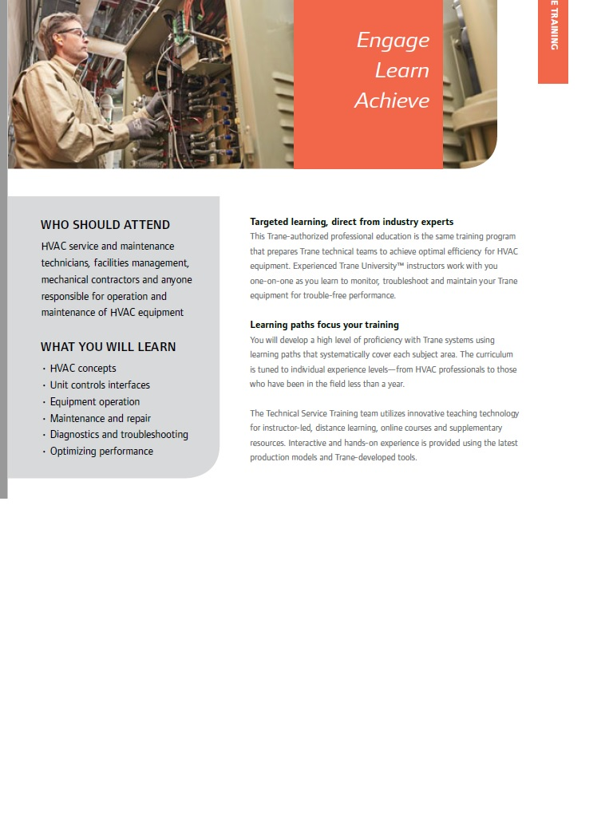
TRANE TECHNICAL SERVICE TRAINING MORE DETAILS AND TO REGISTER CLICK http://tinyurl.com/km74bql

